**Mitchell International Software Development Engineering Internship Coding Challenge** **Submitted By: Keerti Keerti**

**VEHICLE APPLICATION**

**Web Architecture**

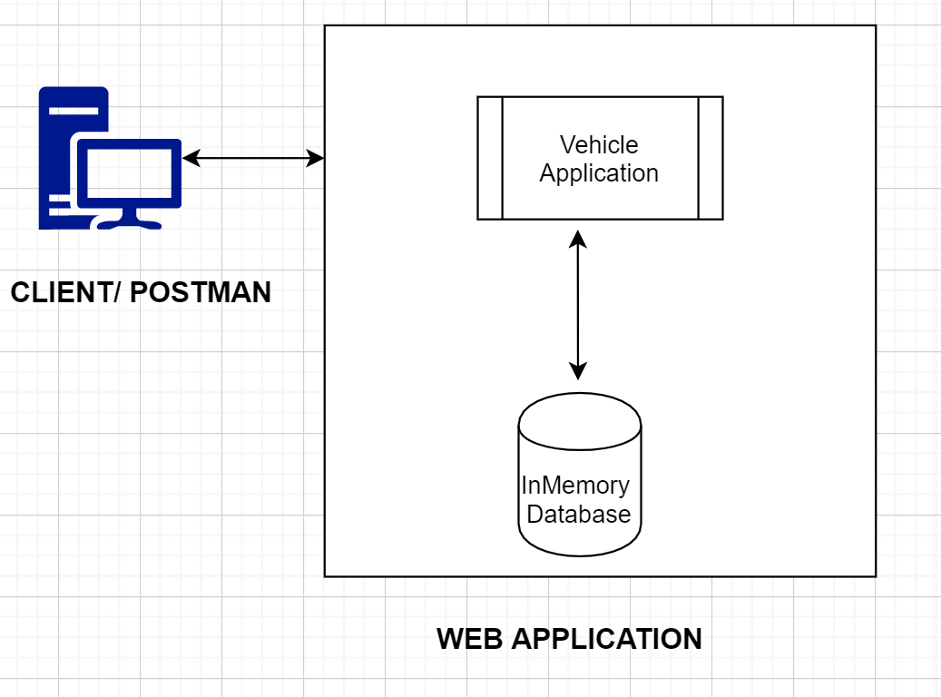

**Module Description:**

**Vehicle Application**: Built various CRUD operations using Spring Boot Framework.

**H2 Database:**  This is open source, relational database system written in java and embedded into the Vehicle Application using Spring boot.

**Client/ Postman:** One can use the APIs mentioned and call the application functionalities.

**Vehicle Object:**

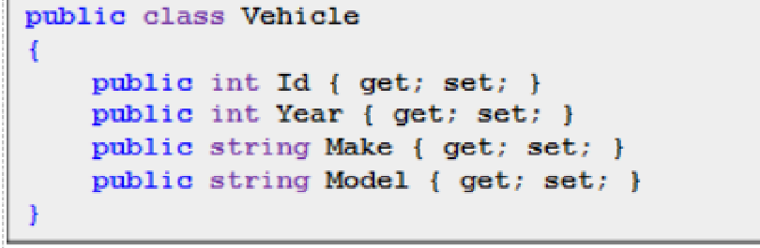

**Service available to the end users:**

1. **GET vehicles** 
   1. **API:**  <http://localhost:8080/vehicles>

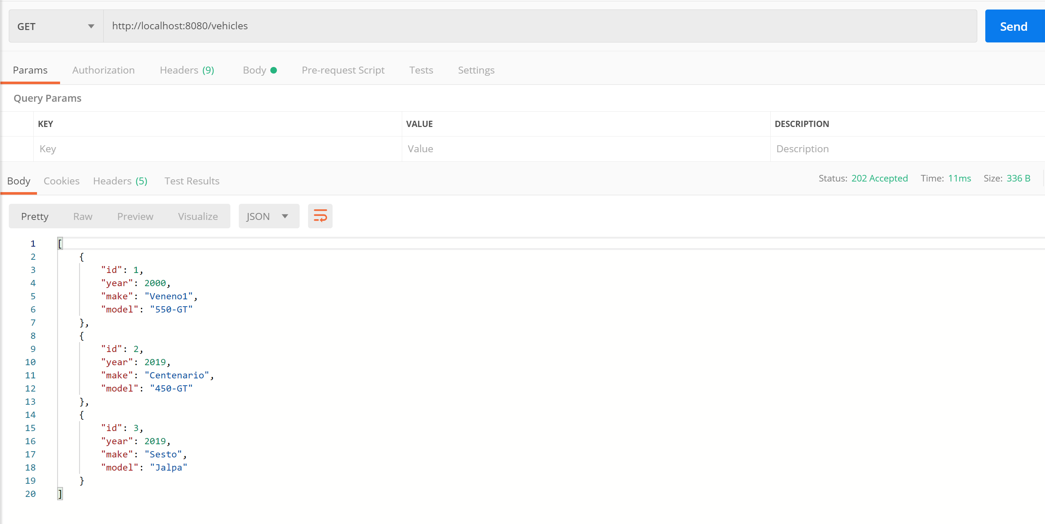

1. **GET vehicles/{id}**
   1. **API:** <http://localhost:8080/vehicles/1>

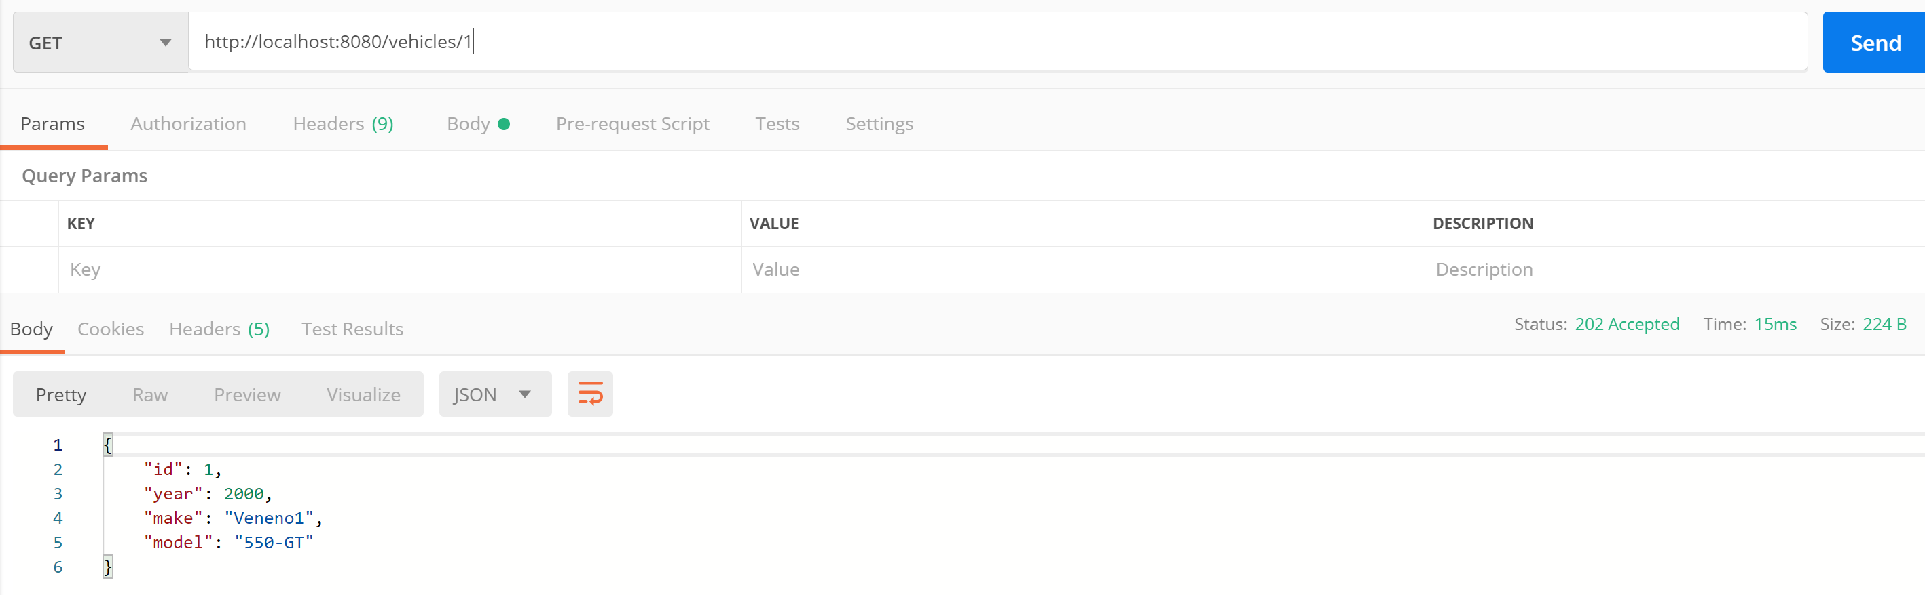

1. **CREATE vehicles**
   1. **API:** <http://localhost:8080/createVehicle>
   2. In the body :

{

"id": 6,

"year": 2019,

"make": "",

"model": "650-GT"

}

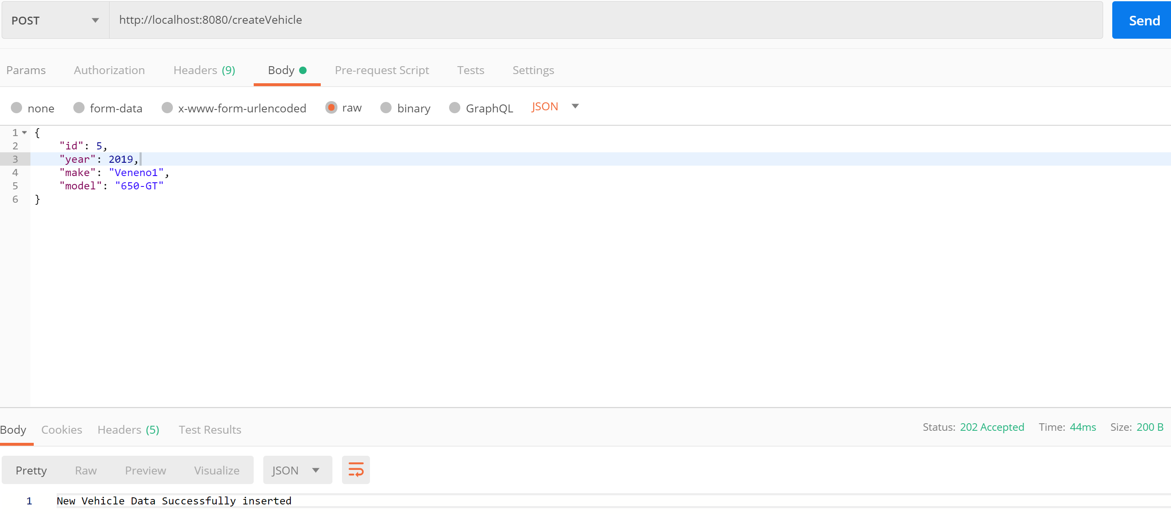

1. **UPDATE vehicles**
   1. **API:** <http://localhost:8080/updateVehicleInfo>

**In body :**

{

"id": 1,

"year": 2017,

"make": "Veneno1",

"model": "550-GT"

}

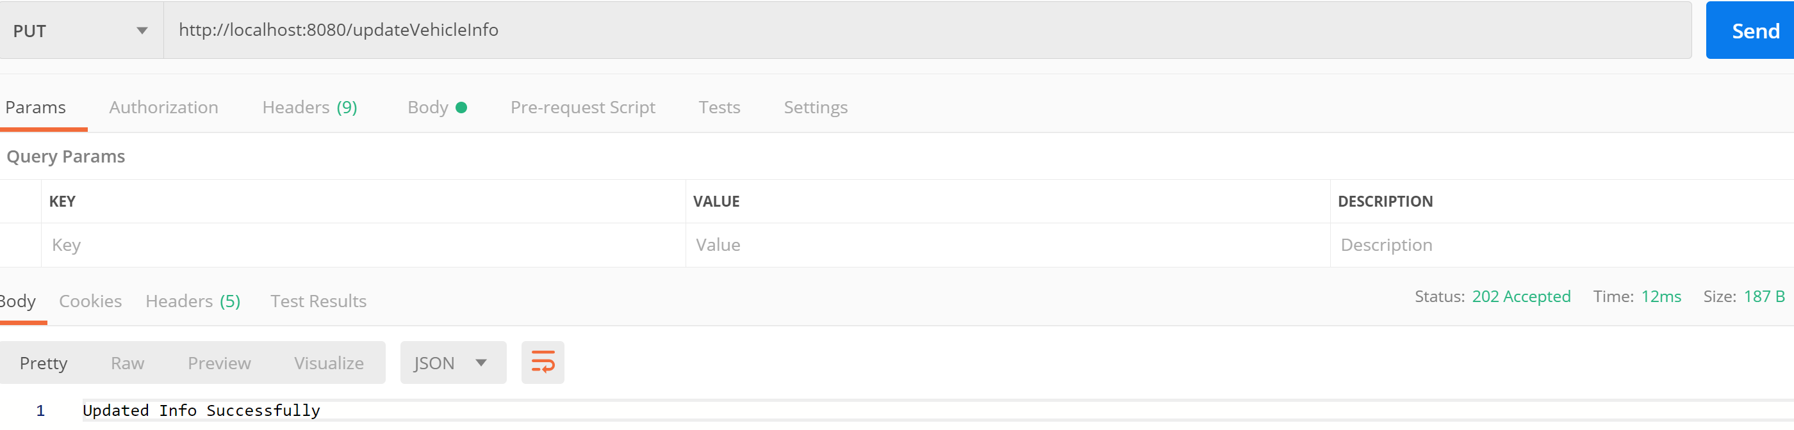

1. **DELETE vehicles/{id}**
   1. **API:** <http://localhost:8080/deleteVehicleInfo/1>

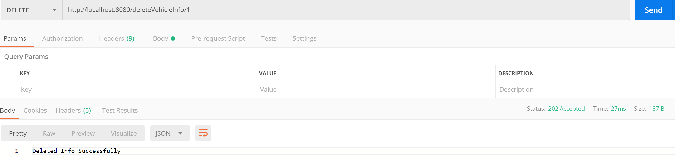

**Execution Instruction:**

**Option 1]** Run the jar file using the following command **(JDK 1.8 is required)**

**>java -jar VehicleApplication-0.0.1-SNAPSHOT.jar MitchellChallenge.VehicleApplication.VehicleApplication**

Then run the APIs mentioned in the postman application to see the outputs.

**Option 2]**

Getting Started

The following instructions will help you in setting up the project on your local machine.

* Download and extract the source code.

* Open the application.properties file under linked in this repository

* Update the properties with database name, username and password.

* The following link helps you to check the database.

http://localhost:8080/h2/login.jsp?jsessionid=756c6784b23d5175e8db03bd63fb1440

* Enter the newly set password and username and connect to the database.

Run the Application.java file

From the postman: enter the given URIs and send them to see the output